Public education is always a key driver of school performance in the United States. While there are a lot of students' efforts and quality of instruction put in, they are influenced by the socioeconomic environment. This project aims to answer the extent to which community socioeconomic factors predict a high school average ACT score. In this project, Edgap was used along with the National Center for Education Statistics.

Educational outcomes are shaped by how much socioeconomic conditions influence them. There are a couple of factors we could look at, for instance, the income of a household, poverty metrics, or school resources could also be considered.

From the histogram, income vs free/reduced lunch showed it is skewed to the right, which could indicate the inequality in the economy with low-income families. The ACT scores graph is normally distributed. This could mean most academic performances are not that different across regions. Unemployment and college education showed skewed distribution, which leads to how family structure influenced performance in education, especially when low-income families could prioritize trade work over performing well in school. 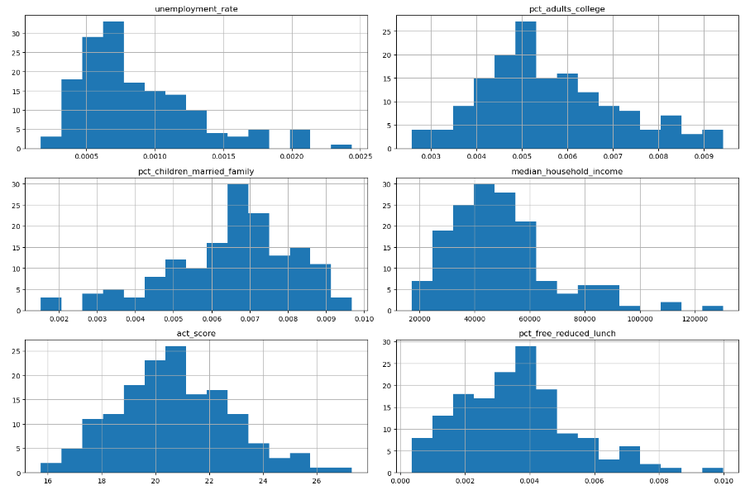

The correlation Matrix provided a strong relationship between household income and ACT score. It also offered a negative relationship between income and free lunch., These indications could mean that wealthier areas tend to perform better due to the accessibility of resources that students need

. 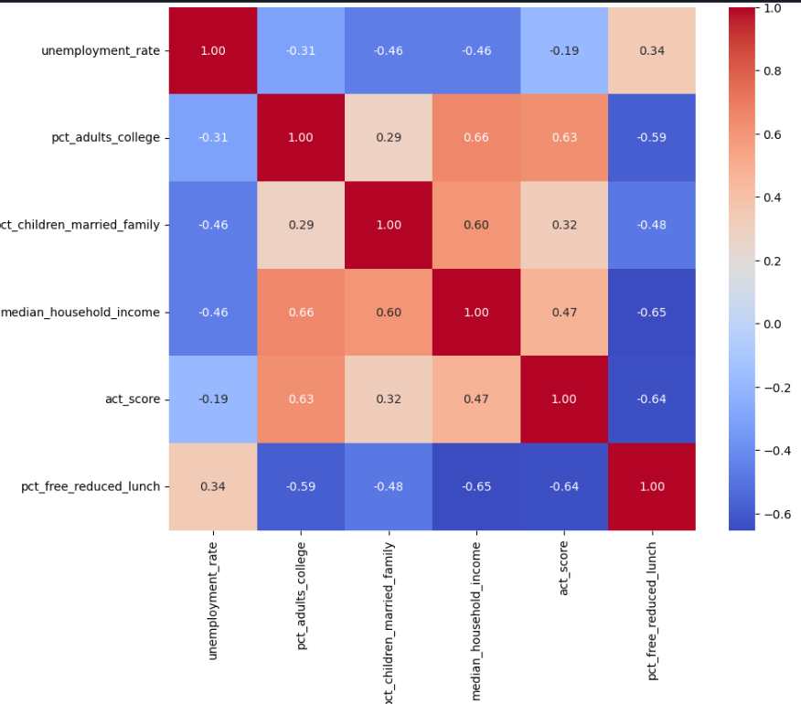

Lastly, the residual and fitted value plot showed no clear trend. The graph is centered around zero and spread uniformly.

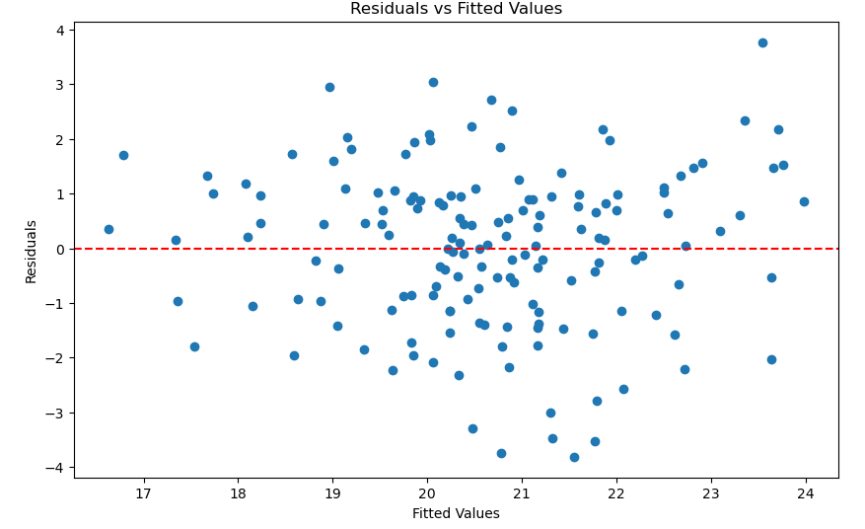

In conclusion, the analysis reveals a strong relationship between socioeconomic and educational outcomes. Income and adult education are strong predictors of student academic performance, while other indicators show an inverse effect. The regression model showed validity based on residual predictions, and it is also a reliable further prediction or policy simulation.